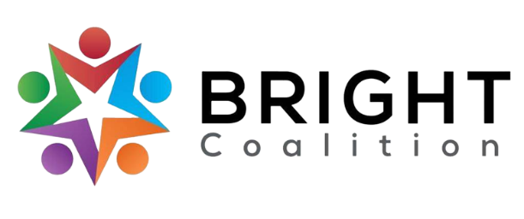
March 14th, 2023
Meeting Notes

Agenda available here. Accompanying PowerPoint available by request to Ashli McCarty (Ashli.mccarty@barrenriverhealth.org).

Beet Box Market lunch provided by Med Center Health Scottsville.

Meeting facilitated by Annette Runyon.

Board Introductions – led by Annette Runyon.
New Member introductions.
Committee Sessions.
- Finance – led by Matt Hunt.
  - $1,500 budget for June event. Lunch will be sponsored by German American Bank.
- Data and Survey – led by Susan Eagle.
  - Setting goals and objectives for June event.
  - Structuring post-event evaluation based on goals and objectives.
- Welcoming – led by Amanda Howard.
  - Invite cards will provided for each BRIGHT member for June event.
    - Each BRIGHT member is encouraged to invite two people.
- Marketing – led by Ashli McCarty.
  - Planning on a Facebook advertisement, radio PSA and print advertisements in local newspapers and magazines to promote June event.
  - Hoping to have a representative from BRIGHT to do an interview on WBKO or WNKY to promote June event.
  - Considering the purchase of BRIGHT yard signs to reuse for future events.
  - Considering a fundraiser for BRIGHT funds.

Special Presentation – presented by Jeff Moore.
- Working in partnership with Michael Baker International to expand rural transit in BRADD counties.
- Share the BRADD Regional Transit Feasibility Survey! Responses will be accepted until April 7th.
  - https://www.surveymonkey.com/r/BRADDSurvey
  - https://www.surveymonkey.com/r/BRADDEspanol

Focus Area Sessions.
- Tobacco
  - Luncheon with elected officials next week for the Simpson County Smoke-Free Ordinance (Strategy 5.1.2).
- Substance Use
  - Narcan to be supplied at WKU resident halls. Resident Assistants will be trained to administer (6.2.3).
  - 117 Narcan kits and 170 HIV tests administered at Healthy Days at WKU (6.2.3).
  - Narcan now available at schools via School Resource Officers (6.2.3).
- Diabetes
  - On track with current strategies.
- Nutrition
  - Working towards establishing seed libraries at county extension offices (1.3.1).
  - Seed library field trip with Med Center Health Adult Daycare next week!
- Physical Activity
  - Promoting BRADD Transit Survey.
  - Working to establish walking groups (2.2.2).
  - Bike Rodeo and Repairs at Kereiakes Park, April 15th (2.2.1).

CHIP Introduction – led by Annette Runyon.
Annette introduced the CHIP and CHA to new members by showcasing the hard copy. The purpose of the CHIP was also explained.

Meeting Adjournment.

Action Items
- Promote June event by inviting two people per BRIGHT member.
- Share the BRADD Regional Transit Feasibility Survey until April 7th.
- Continue to invite community members to join the BRIGHT Coalition.
- Support the BRIGHT Coalition’s Facebook page!

