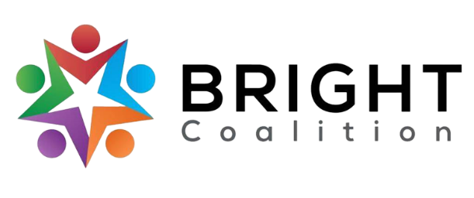
December 12th, 2023
Board Meeting Notes

Email Amanda Reckard for accompanying agenda and PowerPoint.

Lunch from Chick-Fil-A, sponsored by Barren River District Health Department.

Meeting facilitated by Annette Runyon.

Introductions
Med Center Health, Fairview Community Health, National Alliance on Mental Illness, Med Center Adult Day Center

Announcements
- Sponsorship Packets
  - We’re looking for folks to donate to BRIGHT! If you would like to share the sponsorship packet with a company, email Amanda.Reckard@barrenriverhealth.org .
- Committees — join one!
  - Welcoming — contact Amanda Howard
  - Marketing — contact Ashli McCarty
  - Data & Survey — contact Susan Eagle
  - Finance — contact John Lillybridge
- Community Health Assessment
  - Survey will go live by Sept. 1st, 2024.
  - Member input is needed for where/how to distribute surveys.
  - Data and survey meeting at 9 AM on January 16th, Café Kindness in Bowling Green.

Special Presentation — Med Center Adult Day Center
- Reach out to Allison Cash for video presentation.

Breakout Sessions
- Diabetes
  - Gathering data at the end of the year to ensure they reached goals
  - Evaluating goals to edit/update
- Mental Health
  - Brainstormed a list of mental health resources in the area
- Physical Activity
  - Spread awareness of other physical activity organizations and their events
  - Long term, host a “wellness day” next summer to encourage physical activity and educate public about local resources
- Nutrition
  - Currently sharing recipes on BRIGHT Coalition Facebook page
  - Brainstorming ways to encourage urban gardening
- Substance Use
  - Installing Naloxbox’s in our community through BRDHD and Lifeskills
- Tobacco
  - Logan County Library preparing for Radon Awareness programs

Meeting Adjournment

Action Items
- Join the BikeWalk BG winter walking program!
- Bring winter accessory donations to Fairview Community Health this Saturday, December 16th.
- Connect with us on Facebook and LinkedIn!

