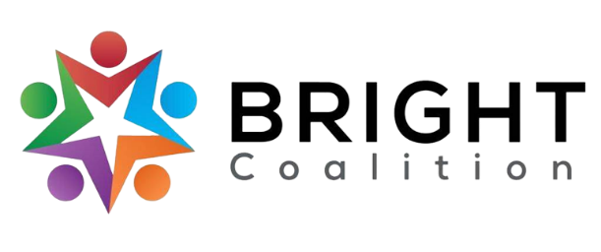
April 11th, 2023
Meeting Notes

Agenda available here. Accompanying PowerPoint available by request to Ashli McCarty (Ashli.mccarty@barrenriverhealth.org).

Panera Bread lunch provided by Med Center Health.

Meeting facilitated by Annette Runyon.

Committee Updates – Board Members
- Welcoming
  - Materials for June event to be ordered before May meeting.
  - RedCap to be used for event registration.
  - Invites to be released within the next two weeks (Ashli).
- Data & Survey – presentation by Susan Eagle.
  - Rough draft of post-event evaluation presented with the following goals.
    - Determine effectiveness of June event.
    - Attendee intent of joining/supporting the BRIGHT Coalition.
    - Increase attendee self-efficacy of advocacy activities.
  - Letter writing activity for June.
    - Policy vs. Intervention Program —each table brainstorms issues pertaining to their organization, in which Susan helps decipher ideas between policy and intervention.
    - Teach attendees how to then write a letter advocating a policy.

Focus Area Sessions
- Tobacco
  - Luncheon with elected officials rescheduled for the Simpson County Smoke-Free Ordinance (Strategy 5.1.2).
    - New date is April 24th. Encourage people to RSVP!
  - In Bowling Green, do non-smoking areas include vaping?
  - Pursuing partnership with PAE (Parents Against E-Cigarettes) to educate parents on the dangers of vaping (4.1.1).
- Substance Use
  - Cave City approved SSP Mobile Unit to operate within the city (6.1.1).
  - Goal – Have Narcan in all eight BRDHD counties by June.

- Diabetes
  - Editing goals and objectives in CHIP.
  - Looking to evaluate 2022’s activities.
- Nutrition
  - Working towards establishing seed libraries at county extension offices (1.3.1).
    - Virtual meeting conducted with Metcalfe County Extension Office to introduce the idea of a seed library.
    - Seed library now at Metcalfe County Public Library!
  - Seed library field trip and raised bed gardens with Med Center Health Adult Day Center – SUCCESS!
    - Watch and share the news story here: https://www.wnky.com/med-center-health-adult-day-center-rolls-up-their-sleeves-to-garden/ .
  - Creating recipe book – recipes are compiled, in the production stage.
  - Possible goal – have seed libraries at each health department.
- Physical Activity
  - Looking to partner with WCPL summer reading program.
  - Making edits to goals and objectives.
  - Bike Rodeo and Repairs at Kereiakes Park, April 15th (2.2.1).

Meeting Adjournment.

Action Items
- Promote June event by inviting two people per BRIGHT member.
- Consider attending or invite others to attend the luncheon for the Simpson County Smoke-Free Ordinance.
- Continue to invite community members to join the BRIGHT Coalition.
- Support the BRIGHT Coalition’s Facebook page!

