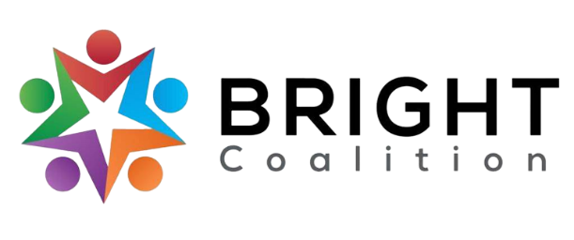
May 9th, 2023
Meeting Notes

Accompanying PowerPoint available by request to Ashli McCarty (Ashli.mccarty@barrenriverhealth.org).

JD’s Bakery lunch provided by Med Center Health.

Meeting facilitated by Annette Runyon.

Introduction
Special Presentation – Jeanna Phelps, Barren River District Health Department.
- Med Center Health Adult Day Center
  - The raised bed gardens are sprouting and the ice cream cones are decomposing!
  - Continuing to conduct activities related to the garden – ex. Making snacks with ice cream cones and “dirt” (graham cracker).

June Workshop Updates
- All BRIGHT members must register for June! Register here or on the website.
- Requests for questions for panelists. Send to Ashli McCarty.

Focus Area Discussion
- Each group completed edits on a copy of the CHA/CHIP. New edits will be included in the newly printed CHA/CHIP.

Meeting Adjournment

Action Items
- Each BRIGHT member invite two people the June workshop! View our invite wish list here.
- Register for June workshop here.
- Support the BRIGHT Coalition’s Facebook page!

