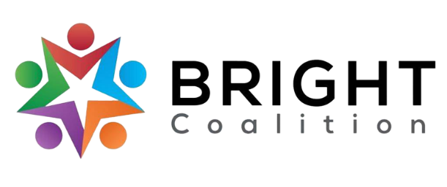
January 9th, 2023
Meeting Notes

Email Amanda Reckard for accompanying agenda and PowerPoint.

Lunch from Jimmy John’s.

Meeting facilitated by Sarah Widener, BRIGHT Coalition Vice Chair.

Introductions
RTI International, Logan County Public Library, Barren River District Health Department.

Announcements
- Sponsorship Packets
  - We’re looking for folks to donate to BRIGHT! If you would like to share the sponsorship packet with a company, email Amanda.Reckard@barrenriverhealth.org .
- Committees — join one!
  - Welcoming — contact Amanda Howard
  - Marketing — contact Ashli McCarty
  - Data & Survey — contact Susan Eagle
  - Finance — contact John Lillybridge
- Community Health Assessment
  - Survey will go live by Sept. 1st, 2024.
  - Coalition to sign a contract with Grantibly (Lauren McClain), for survey writing and distribution services.

Special Presentation — Logan County Public Library, Radon on the Radar.
- Not only awareness, but action is needed for radon exposure.
- Radon — naturally occurring gas, second leading cause of lung cancer.
  - Over 1,000 Kentuckians are diagnosed with radon-induced lung cancer each year.
- Kits provided by Logan County Public Library for no charge.
- Contact King Simpson for accompanying presentation.

Housekeeping
- Tobacco and Substance Use breakout groups to combine.
- Binder updates — social media update, mind maps, etc.

Breakout Sessions
- Substance Use & Tobacco
  - Logan and Edmonson County SSP, approved by Board of Health but needs City Council approval.
  - Naloxbox’s ordered — searching for places to plant. Suggestions welcome!
  - Continuing Narcan trainings through BRDHD and Lifeskills
  - Continuing vaping education and signage in Logan Co. schools
- Nutrition
  - Continuing “Fun Food Fridays” on BRIGHT Coalition Facebook page.
- Physical Activity
  - Seeking data from coalition for other walking groups in the Barren River area
  - Seeking partnerships with Parks & Recreation in other counties besides Warren
  - Advocacy for physical education requirements in schools
- Mental Health
  - Continuing to develop a mental health resource list
  - Seeking partnerships with mental health agencies
- Diabetes
  - Planning to pull diabetes data from healthcare agencies for diabetes objectives.

Meeting Adjournment

Action Items
- Reach out to Charity Crowe or Cally Stuart for any location suggestions for Naloxbox’s.
- Forward any mental health resources to Amanda Reckard
- Follow and engage with us on BRIGHT Coalition Facebook and LinkedIn!
- Reach out to Amanda Reckard for a sponsorship packet to share.

