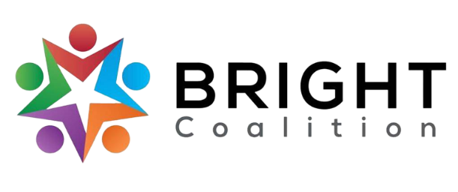
September 12th, 2023
Board Meeting Notes

Email Amanda Reckard for accompanying agenda and PowerPoint.

Lunch from JD’s Bakery provided by Med Center Franklin.

Meeting facilitated by Annette Runyon and Amanda Reckard.

Housekeeping
- Introductions of new members from Humana Medicaid, Target 4 and Bluegrass Counseling Professionals.
- Hanover Research — presented by Qingfang Song.
  - Survey for health professionals to complete, reach out to Qingfang for more information. Flyers distributed at meeting with QR code to survey.
- Sponsorship Packet — presented by Ashli McCarty.
  - Newly-created sponsorship packet presented. Contact Amanda Reckard or Ashli McCarty for suggestions or a copy of the packet.

Special Presentation — Robert Cassman, Bluegrass Professional Counseling, “The State of Mental Health”
- Contact Robert to view the accompanying PowerPoint.

Other Announcements
- Addition of Mental Health Breakout Group at the BRIGHT Coalition!
  - Please invite anyone who you’d think would be interested in joining the mental health group.
- Opioid Abatement Symposium — Sept. 18th at Corvette Museum
- Riverfront Development Meeting — Sept. 20th from 4-6PM at BGMU Conference Center

Breakout Groups
- Diabetes
  - Support Med Center Health’s diabetes support group, occurring periodically. Check Med Center Facebook for more information.
- Mental Health
  - Who can we invite to the table to kickstart this group?
  - Brainstormed ideas for people to contact.
- Physical Activity
  - Continuing to promote BikeWalkBG activities.
  - Supporting BG Greenways development.
- Nutrition
  - In the process of collecting multicultural recipes for ‘Fun Food Fridays,’ which will feature a multicultural and/or healthy recipe on the BRIGHT Coalition Facebook page.
- Substance Use
  - Applied for funding for 40 Naloxboxes and Xylazine strips across the BRADD region.
  - Compiling a list of treatment centers for SSP use.
  - Increased HIV/Hep C testing, addition of extra SSP day in Warren County.
  - Increased education of substance use to local boards of health.
- Tobacco
  - November event for tobacco/vaping cessation.
  - PAVE (Parents Against Vaping E-cigarettes) searching for video testimonials of those who’ve been affected by vaping.

Promotion
- Invite letter — to be sent to potential members.
  - Contact Amanda Reckard ( Amanda.reckard@barrenriverhealth.org ) for a copy.
- BRIGHT LinkedIn — to connect with more professionals in our area.
  - Connect with us at www.linkedin.com/company/brightcoalition

Meeting Adjournment

Action Items
- Promote sponsorship packet with contacts.
- Invite people to join the mental health group.
- Connect with us on Facebook and LinkedIn!

