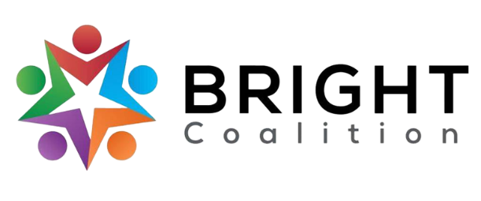
August 8th, 2023
Meeting Notes

Accompanying PowerPoint available by request to Ashli McCarty (Ashli.mccarty@barrenriverhealth.org).

Lunch from JD’s Bakery provided by A Plus Health.

Meeting facilitated by Annette Runyon.

Introductions
- Welcome new members! We’re so excited you decided to join us!

Special Presentation – Sherman Brown, McCarty Strategic Solutions
- Treat and Reduce Obesity Act — “This bill expands Medicare coverage of intensive behavioral therapy for obesity. The bill also allows coverage under Medicare's prescription drug benefit of drugs used for the treatment of obesity or for weight loss management for individuals who are overweight.”
  - If you’re interested in sending a letter or contact lawmakers to support this act, please reach out to Sherman at sherman@mssgov.com .

Mini-Grant Recipients 2023
- The three recipients of the BRIGHT Coalition Annual Workshop Mini-Grant are the following organizations: HOTEL INC., Barren County YMCA, and Refuge BG. Congrats!
  - For more information about the grant projects, contact Ashli McCarty for the PowerPoint slides.

Fundraising
- BRIGHT is looking to add money to its account. Any fundraising ideas?
  - Casino Night
  - Family friendly fall festival — line the streets with food trucks, offer flu shots, check blood pressure, etc.
  - ‘BRIGHT Night’ — more adult-friendlier with cocktails, a date-night event.
  - Seek sponsorships from local businesses, sponsorship packet.

Committees
- Sign up for committees!
  - Data & Survey — help evaluate event success through survey, objective measures, etc.
  - Marketing — contribute ideas for social media, the website and any BRIGHT Coalition merchandise.
  - Finance — monitor the bank account and help lead fundraising efforts.
  - Welcoming — create a hospitable environment for new members, assist checking in members and hospitality/registration for events.

Focus Area Discussion
- Diabetes
  - On target with objectives.
  - Brainstorming ideas for social media content.
- Nutrition
  - On target with objectives.
  - In the process of gathering recipes for cookbook and for social media distribution, with recipes focused on cultural foods as well.
- Physical Activity
  - Welcome new members from Warren County Parks and Recreation, Barren County YMCA and Edmonson County P&R!
- Substance Use
  - KY overdose death numbers down for the first time in 4 years!
  - Western KY Marijuana Prevention Summit — Oct. 19th at Lake Barkley State Park.
- Tobacco
  - Shifting focus from tobacco cessation to vaping and nicotine use.

AHEC Pop-Up Clinic
- Event at Teranga Academy on August 26th and 27th. Reach out to Emily Anne Pride Sutton if you want to volunteer or if you know doctors/dentists/optometrists who can volunteer their time!
  - Call Emily at 270-745-2193.

Meeting Adjournment

Action Items
- Tag BRIGHT in social media posts, or reach out to Ashli McCarty or Olivia Harden, so BRIGHT Coalition can promote local events related to our focus areas! Facebook
- Connect with us on LinkedIn!
- Contact Amanda Reckard ( Amanda.reckard@barrenriverhealth.org ) for any fundraising ideas.

