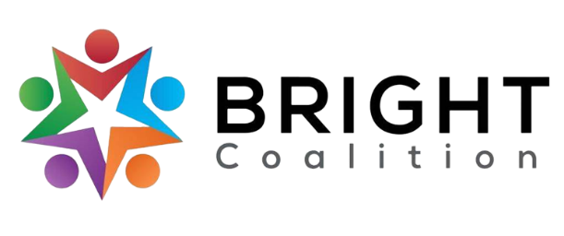
October 10th, 2023
Board Meeting Notes

Email Amanda Reckard for accompanying agenda and PowerPoint.

Lunch from Beet Box Market provided by Bluegrass Professional Counseling.

Meeting facilitated by Matt Hunt.

Housekeeping
- New member introductions from The Foundry, Allen Co. Health Department, Fairview, and Grantibly.
- Sponsorship Packets
  - All members are encouraged to reach out to one contact and propose a sponsorship opportunity.
- Committees
  - If you’re interested in joining one, reach out to the chair!
    - Marketing — Ashli McCarty
    - Data & Survey — Susan Eagle
    - Finance — John Lillybridge
    - Welcoming — Amanda Howard
  - Data & Survey update
    - Met last month and created a rough schedule of gathering qualitative data.
    - Will meet each third Tuesday at 9 AM at Harvest Bakery and Café.
    - BRIGHT member contacts will be important in gathering this data! If you would like to invite a stakeholder to CHA planning, please reach out to Susan or attend a D&S meeting!
Reflection of Opioid Symposium — Matt Hunt, Eric Sexton and Eric Hagan.
- Funding for opioid came from attorney general office from a big pharma settlement, specifically Pardue.
- Eric H. tasked with uniting community leaders in opioid abatement, decided to focus on prevention/treatment/recovery, yet also assurance of care.
- Summary of opioid symposium on BRADD website (www.bradd.org)
  - Go to www.planning.bradd.org to sign up for an opioid abatement committee.
  - Mental Health Cooperative (Nashville, TN) and Life Learning Community (Northern KY) field trips.

Project and Programs Available — Laura Edwards and Sheila Barnard, Prevention and Promotion Branch Division of Substance Use
- See copies of Project and Programs on the front table.

Breakout Groups
- Diabetes
  - Virtual DSMES classes to begin soon. Stay tuned for updates!
- Mental Health
  - In the process of brainstorming mental health resources for a small print resource guide.
- Physical Activity
  - Warren County Parks & Recreation working with community farmers for public garden space, cycling clubs and so forth.
  - Bicycle education curriculum being created with BRDHD (Madison).
- Nutrition
  - In the process of collecting multicultural recipes for ‘Fun Food Fridays.’
  - Searching for in-season recipes.
- Substance Use
  - Received funding for 40 Nalox-boxes across the BRADD region!
    - If you have good ideas about where Nalox-boxes can go in our community, email Amanda or Charity!
  - Awarded $8,000 from an equity grant to purchase Xylazine strips (drug that cannot be reversed by Narcan) and more harm reduction supplies.
  - Allen Co. to be pilot site for Icelandic Prevention Model, based on monitored youth activity and positive adult-child interaction.
    - Partnering with WKU to be pilot site.
- Tobacco
  - Still strategizing about how to refocus with vaping prevention/education.
  - www.parentsagainstvaping.org — education resources for whoever may need it.

Promotion
- Invite letter — to be sent to potential members.
  - Contact Amanda Reckard ( Amanda.reckard@barrenriverhealth.org ) for a copy.
- BRIGHT LinkedIn — to connect with more professionals in our area.
  - Connect with us at www.linkedin.com/company/brightcoalition

Meeting Adjournment

Action Items
- Promote sponsorship packet with contacts.
- Send ideas for Naloxbox locations to Amanda Reckard or Charity Crowe.
- Invite people to join the mental health group.
- Connect with us on Facebook and LinkedIn!

